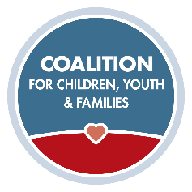
Recruitment Series Self-Paced
Exercises for Recruitment Video 2

Consider these questions as they relate to the video on “support and development of foster families” and “customer service response systems.” Please also consider how these same questions might apply to your relative caregivers.

- How do you keep families engaged during the licensing process?

- If you were going to survey your existing foster families about whether they feel like “part of the team” what would you ask?

- In what ways is your agency supportive towards your current foster families? (both within child welfare, and in the greater agency at-large)

- How do you encourage your foster families to connect with each other?

- Does your agency utilize “development” strategies with your foster families? (e.g., individualized training plans, “promoting” families to teen care, identifying and training Foster Parent Champions, etc.)

- What are the signs you see in foster families that help you identify compassion fatigue?

- What self-care strategies do you provide to your current foster families?

- Do you offer respite resources? How is respite encouraged? Are families encouraged to take breaks from taking new placements when needed?

- What are the unique challenges as well as strengths you’ve experienced with your relative caregivers?

- How do you support and provide resources specific to relative caregiver families?

- In what ways have you engaged your relative caregivers to consider non-relative foster care?

- What does your agency do well with your current response system for prospective foster families, and where might you improve? What are gaps you have observed?

