As a relative caregiver, you may have questions regarding your legal rights, or you may want legal assistance as you navigate the child welfare system and court process. While it is not required to obtain legal representation, you might find it beneficial to consult with an attorney about your role as a caregiver and the rights that you may have. ***Nothing in this fact sheet should be considered legal advice from the Department of Children and Families (DCF)***. ***Please consult with an attorney with any legal questions.***

## FAQs Do I need an attorney?

Depending on the circumstances of your case, you may or may not need an attorney to represent you. There are pros and cons to hiring an attorney – a pro being that you have an advocate who understands the legal system, and a con being that hiring an attorney can be costly.

## Am I eligible for a court-appointed attorney?

Typically, relative caregivers are not eligible for court-appointed legal representation. In some circumstances, the court may appoint an attorney for the child in your care and/or the child’s parents. Right to counsel is dependent on the type of case and is determined by local court procedure and state statute.

## Am I a party to the case involving the relative child in my home?

Depending on your situation, you may or may not be a party to the case involving the relative child in your home. If the child is placed in your home under a court order through the child welfare or youth justice system, you may have the opportunity to be heard during certain hearings, such as permanency hearings, even though you are not a party to the case. You may be a party to the case if you have guardianship of the child.

## Who can answer my legal questions?

If you are working with a child welfare agency you may be able to ask general “what to expect” questions. However, they cannot give legal advice. There may be attorneys that are involved in the child’s case, such as the guardian ad litem (GAL) or Corporation Counsel. They are not hired or appointed to represent YOU, and will typically not, and should not, provide you legal advice. If you have questions regarding your own rights, you should seek out legal services of your own.

## What legal services are available to me?

While it is uncommon for relative caregivers to obtain a court-appointed attorney, there may be legal resources available to you in your area. If you do not have the financial means to hire an attorney, your local courthouse may have more information on how to obtain free or reduced-cost legal representation, or it might offer free walk-in legal clinics where you can obtain answers to your legal questions. Some attorneys may offer sliding-scale fees, limited-scope representation, or may agree to take a case pro-bono.

## What information should I share with an attorney?

To adequately consult or represent you on your legal matter, an attorney will likely ask questions to understand your role as caregiver to the relative child in your home. They will want to know your relationship to the child and how the child came to be living in your home. It will be important to know your status as a relative caregiver, such as whether you have guardianship of the child or if the child is involved in the child welfare system. If you need assistance in determining what type of caregiving arrangement you have, you can visit the Wisconsin Kinship Navigator Online Portal at <https://dcf.wisconsin.gov/kinship/navigator>.

## Types of relative caregiving arrangements:

* Relative caregiver through an informal family arrangement
* Relative caregiver receiving kinship care payments (voluntary or court ordered)
* Relative caregiver not receiving kinship care payments

Kin**FACTS:**

**WISCONSIN**

**Legal**

* Relative caregiver licensed as a foster parent
* Relative caregiver not licensed as a foster parent
* Relative caregiver with guardianship under Wis. Stat. § 48.977
* Relative caregiver with subsidized guardianship
* Relative caregiver with guardianship under Wis. Stat. § 48.9795
* Relative caregiver who has adopted

## General Legal Resources

**State Bar of Wisconsin:** <https://www.wisbar.org/Pages/default.aspx>

**Wisconsin State Law Library:** <https://wilawlibrary.gov/>

**Marquette University Law School Library:** <https://law.marquette.edu/law-library> **University of Wisconsin Law School Library:** <http://library.law.wisc.edu/>

**Wisconsin Local Court Rule:** <https://www.wisbar.org/Directories/CourtRules/Pages/Circuit-Court-Rules.aspx>

**Wisconsin Court System Self-Help Center:** <https://www.wicourts.gov/services/public/selfhelp/index.htm>

## Wisconsin Legal Services Firms

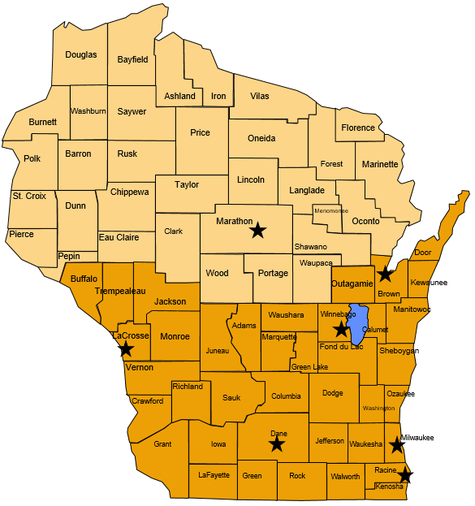**Wisconsin**



**Judicare**

### Wausau

(Provides legal services to the northern 33 counties)

**Legal Action of Wisconsin** Green Bay



### La Crosse Oshkosh Madison Milwaukee Racine

#### Wisconsin Judicare:

<http://www.judicare.org/>

#### Legal Action of Wisconsin:

<https://www.legalaction.org/>

#### Disability Rights Wisconsin:

<http://www.disabilityrightswi.org/>

#### ABC for Health:

<https://www.safetyweb.org/>

#### Kids Matter, Inc.:

<https://kidsmatterinc.org/>



The Department of Children and Families is an equal opportunity employer and service provider. If you have a disability and need to access services, receive information in an alternate format, or need information translated to another language, please call the Bureau of Permanence and Out of Home Care or Division of Safety and Permanency at 608-422-7000. Individuals who are deaf, hard of hearing, deaf-blind or speech disabled can use the free Wisconsin Relay Service (WRS) – 711 to contact the department.